A000-Asia-China-Sichuan-Sanxingdui-三星堆-3700-2100 BCE

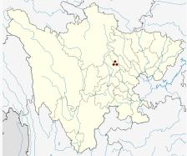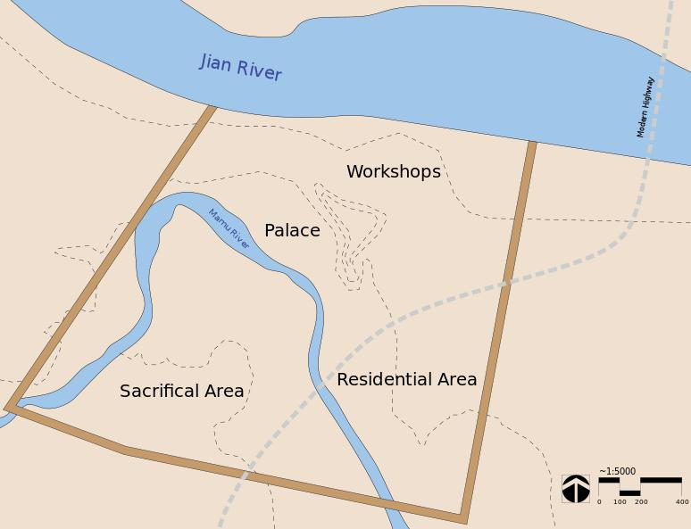

Sanxingdui site (30° 59′ 34.8″ N, 104° 12′ 0″ E). Left, Location in Sichuan Province; right map of city wall enclosing ca 2.6 sq. km. and 4 major cultural areas.

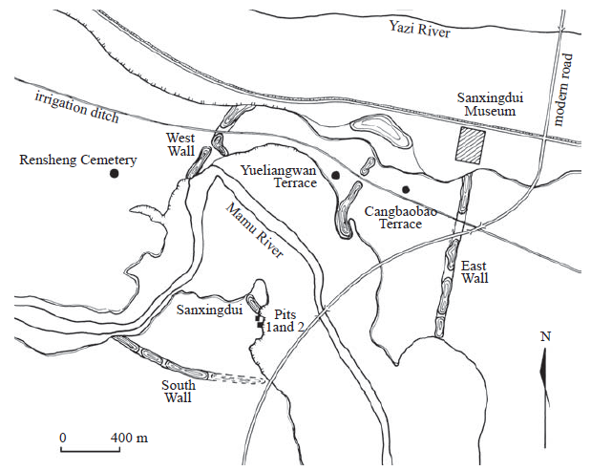

Figure 1. Map of the Sanxingdui site. After Bagley 2001: 24, fig. 1.

Sanxingdui-三星堆 (three star mound) is located about 10 km west of the city of Guanghan

廣漢, which is about 40 km northeast of Chengdu 成都, the capital of

Sichuan province (Sichuan 1999: 9, 15). Spread along the southern

bank of the Yazi River 鴨子河 and both sides of the Mamu River 馬

牧河, the site is presently known to cover an area of 10 to 17 sq. km as

determined by the distribution of artifacts.2 The center of the site is a walled enclosure that measures about 3.5 sq. km (350 ha) (Chen De’an

et al. 1998: 1) (Figure 1). The site is named after Sanxingdui because

of the major excavations in that area in 1980–1981, which established

the basic framework of periodization and cultural definition of the site,

and because of the discovery there in 1986 of K1 and K2, two “sacrificial

pits” filled with immense material wealth. These two pits revealed

the site to be a center of an early Bronze Age civilization previously

unknown.3

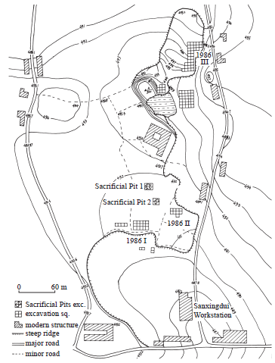

Figure 2. Excavation loci at Sanxingdui in 1986. Adapted from Sichuan 1999: 13, fig. 4.

For the absolute dating of the Sanxingdui site, the report of the

1980–81 excavations (including remarks about the 1982 excavations)

relied on the following evidence (Sichuan 1987a: 249). A calibrated

radiocarbon date was obtained from a sample of charcoal from Phase

I remains, which gives the uncalibrated radiocarbon date of 4075}100

BP (with 5730 half-life) and the calibrated date of 4500}100 BP.22 The

fine spiral pattern decorating some of the pottery vessels of Phase III are similar to the *leiwen* 雷紋 (rectilinear spirals) on Shang bronzes. Besides,

the upper stratum of the 1982 excavations yielded pottery vessels with

pointed bottom, the likes of which had appeared in abundance at the

Shuiguanyin 水觀音 site in Xindu 新都 County, a site that can be dated

to the end of the Shang period or the beginning of the Western Zhou

period through associations in bronze.23

3700–3370 calBCE (ZK-2591, Charcoal: wood)

3497–3040 calBCE (ZK-2330, Charcoal: wood)

2873–2502 calBCE (BK86046, Charcoal: wood)

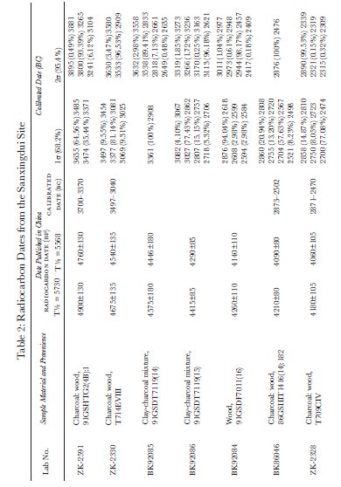

*References cited*

Asahi 1998: Asahi Shimbunsha 朝日新聞社 (editor) (1998). *Sanseitai—*

*Chūgoku 5000 nen no nazo, kyōi no kamen ōkoku* 三星堆*—*中国 5000 年

の謎・驚異の仮面王国 (Sanxingdui—China’s 5000-year old mystery,

kingdom of startling masks). Tōkyō: Asahi Shimbunsha.

Bagley, Robert (1987). *Shang Ritual Bronzes in the Arthur M. Sackler Collections*.

Washington, DC: Arthur M. Sackler Foundation.

Bagley, Robert (1988).“Sacrificial pits of the Shang period at Sanxingdui

in Guanghan County, Sichuan Province.” *Arts Asiatiques* 43 (1988):

78–86.

Bagley, Robert (1990). “A Shang city in Sichuan Province.” *Orientations*

(November 1990): 52–67. [Chinese translation published in Li Shaoming

et al. 1993: 69–75].

Bagley, Robert (1999). “Shang archaeology.” In Michael Loewe and

Edward L. Shaughnessy (eds.), *The Cambridge History of Ancient China*,

pp. 124–231. Cambridge: Cambridge University Press.

Bagley, Robert (editor) (2001). *Ancient Sichuan: Treasures from a Lost Civilization*.

Seattle: Seattle Art Museum in association with Princeton

University Press.

Barnard, Noel (1990). “Some preliminary thoughts on the significance

of the Kuang-han pit-burial bronzes and other artifacts.” *Beitrage zur*

*allgemeinen und vergleichenden Archaologie* 9–10 (1990): 249–279. [Chinese

translation published in *Nanfang minzu kaogu* 南方民族考古 5 (1992):

25–66.]

Beijing 1996: Beijing Daxue Kaoguxi Tanshisi Shiyanshi 北京大學考

古系碳十四實驗室 (1996). “Tanshisi niandai ceding baogao (yiling)

碳十四年代測定報告 (一○) (Report of radiocarbon dates, No. 10)”.

*Wenwu* 文物 1996.6: 91–95.

Bowman, Sheridan (1990). *Radiocarbon Dating*. London: British Museum

Publications.

Chen De’an 陳德安 (1998). “Sanxingdui yizhi de faxian yu yanjiu 三星

堆遺址的發現與研究 (Discovery and study of the Sanxingdui site).”

*Zhonghua wenhua luntan* 中華文化論壇 1998.2: 57–63. Chengdu.

Chen De’an, Wei Xuefeng 魏學峰, and Li Weigang 李偉綱 (1998). *Sanxingdui:*

*Changjiang shangyou wenming zhongxin tansuo* 三星堆: 長江上游

文明中心探索 (Sanxingdui: Exploring the center of civilization in

the upper reaches of the Changjiang River). Chengdu: Sichuan Renmin

Chubanshe.

Chen Xiandan 陳顯丹 (1988). “Lun Guanghan Sanxingdui yizhi de

xingzhi 論廣漢三星堆遺址的性質 (On the nature of the Sanxingdui

site of Guanghan).” *Sichuan wenwu* 四川文物 1988.4: 9–11, 8.

Chen Xiandan (1989). “Guanghan Sanxingdui yizhi fajue gaikuang,

DEFININg THE CULTURES AT SANXINDUI 183

chubu fenqi—jianlun ‘zao Shu wenhua’ de tezheng jiqi fazhan 廣漢

三星堆遺址發掘概況, 初步分期—兼論 ‘早蜀文化’ 的特徵及其發

展 (Brief account of excavations and preliminary periodization of the

Sanxingdui site in Guanghan—concurrently on the characteristics

of the ‘early Shu Culture’ and its development).” *Nanfang minzu kaogu*

2 (1989): 213–229.

Chen, Xiandan (1999). “The sacrificial pits at Sanxingdui: their nature

and date.” In Roderick Whitfield and Wang Tao (translators and eds.),

*Exploring China’s Past: New Discoveries and Studies in Archaeology and Art*,

pp. 165–171. London: Saﬀron Books.

Chen Xiandan (2001). “Guanghan Sanxingdui dashiji 廣漢三星堆大

事記 (1929–2000.2) (Chronicle of Guanghan Sanxingdui [1929–

2000.2]).” *Zhonghua wenhua luntan* 2001.1: 41–45.

Chen Xiandan and Liu Jiasheng 劉家勝 (2002). “Lun Sanxingdui

wenhua yu Baodun wenhua zhi guanxi 論三星堆文化與寶墩文化

之關係 (On the relationship between the Sanxingdui Culture and

the Baodun Culture).” *Sichuan wenwu* 2002.4: 3–6.

Cheng, Te-k’un [= Zheng Dekun] (1949). “The T’ai-p’ing-ch’ang Culture,

Szechwan.” *Hsieh-ta Journal of Chinese Studies* 1 (1949): 67–81.

Chengdu. Reprinted in Cheng, Te-k’un (1982), *Studies in Chinese*

*Archaeology*, pp. 55–65. Hong Kong: The Chinese University Press.

Chengdu 1997: Chengdu Shi Wenwu Kaogu Gongzuodui 成都市文物

考古工作隊 and Xindu Xian Wenwu Guanlisuo 新都縣文物管理

所 (1997). “Sichuan Xindu Xian Guilinxiang Shang dai yizhi fajue

jianbao 四川新都縣桂林鄉商代遺址發掘簡報 (Preliminary report

of excavation of a Shang period site at Guilinxiang in Xindu County,

Sichuan).” *Wenwu* 1997.3: 24–34.

Chengdu 1998: Chengdu Shi Wenwu Kaogu Gongzuodui, Sichuan

Lianhe

Daxue Lishixi Kaogu Jiaoyanshi 四川聯合大學歷史系考

古教研室, and Xinjin Xian Wenguansuo 新津縣文管所 (1998).“Sichuan

Sheng Wenjiang Xian Yufucun yizhi diaocha yu shijue 四川省

溫江縣魚鳧村遺址調查與試掘 (Survey and test excavation at the Yufucun

site in Wenjiang County, Sichuan.” *Wenwu* 1998.12: 38–56.

Chengdu 2001: Chengdu Shi Wenwu Kaogu Yanjiusuo 成都市文物

考古研究所, and Pixian Bowuguan 郫縣博物館 (2001). “Sichuan

Sheng Pixian Qingjiangcun yizhi diaocha fajue shouhuo 四川省郫

縣清江村遺址調查發掘收獲 (Results of survey and excavation of

the Qingjiangcun site at Pixian County, Sichuan). In Chengdu Shi

Wenwu Kaogu Yanjiusuo (editor), *Chengdu kaogu faxian 1999* 成都

考古發現 1999 (Archaeological discoveries in Chengdu 1999), pp.

146–163. Beijing: Kexue Chubanshe.

Chengdu 2002: Chengdu Shi Wenwu Kaogu Yanjiusuo and Beijing

Daxue Kaogu Wenboyuan 北京大學考古文博院 (2002). *Jinsha*

184 jay xu

*taozhen—Chengdu Shi Jinshacun yizhi chutu wenwu* 金沙淘珍—–成都

市金沙村遺址出土文物 (Panning for treasure at Jinsha—Artifacts

unearthed at Jinshacun, Chengdu). Beijing: Wenwu Chubanshe.

Chengdu 2003a: Chengdu Shi Wenwu Kaogu Yanjiusuo and Pixian

Bowuguan (2003). “Sichuan Pixian Qingjiangcun yizhi fajue jianbao

四川郫縣清江村遺址發掘簡報 (Preliminary report of excavation of

the Qingjiangcun site at Pixian County, Sichuan).” *Wenwu* 2003.1:

56–64.

Chengdu 2003b: Chengdu Shi Wenwu Kaogu Gongzuodui (2003).

“Chengdu Shi Hetaocun Shang dai yizhi fajue jianbao 成都市核桃

村商代遺址發掘簡報 (Preliminary report of excavation of a Shang

period site at Hetaocun in Chengdu).” *Wenwu* 2003.4: 21–25.

Falkenhausen, Lothar von (2002). “Some reflections on Sanxingdui.”

In I-tien Hsing (editor), *Regional Culture, Religion, and Arts before the*

*Seventh Century: Papers from the Third International Conference on Sinology,*

*History Section*, pp. 59–97. Taipei: Institute of History and Philology,

Academia Sinica.

Falkenhausen, Lothar von (2003). “La culture de Sanxingdui: sources

et contacts.” In Paris–Musees (editor), *Chine, l’enigme de l’homme de*

*bronze: Archeologie du Sichuan (XII–III siecle av. j.-c.)*, pp. 47–59. Paris:

Paris–Musees.

Ge, Yan and Katheryn M. Linduﬀ (1990). “Sanxingdui: a new Bronze

Age site in Southwest China.” *Antiquity* 64 (1990): 505–513. [Chinese

translation published in *Sichuan wenwu* 1991.6: 71–77.]

Goepper, Roger (editor) (1995). *Das alte China: Menschen und Gotter im*

*Reich der Mitte*. Essen: Kulturstiftung Ruhr.

Graham, David C. (1934). “A preliminary report of the Hanchow excavation.”

*Journal of the West China Border Research Society* 6: 114–131.

Chengdu.

Henan 2001: Henan Sheng Wenwu Kaogu Yanjiusuo 河南省文物

考古研究所 (2001). *Zhengzhou Shang cheng—1953–1985 nian kaogu*

*fajue baogao* 鄭州商城—1953–1985 年考古發掘報告 (Report of the

1953–1985 excavations of the Shang city at Zhengzhou). Beijing:

Wenwu Chubanshe.

Huang Jiaxiang 黃家祥 (1990). “‘Guanghan Sanxingdui yizhi’ de chubu

fenxi ‘廣漢三星堆遺址’ 的初步分析 (Preliminary analysis of ‘the

Sanxingdui

site at Guanghan’).” *Kaogu* 考古 1990.11: 1030–1036.

Jiang Zhanghua 江章華 (1998a). “Shilun Sanxingdui wenhua Shi’erqiao

wenhua yu zhoulin wenhua de guanxi 試論三星堆文化十二橋文化

與周鄰文化的關係 (Preliminary discussion of the relationships between

the Sanxingdui Culture, the Shi’erqiao Culture, and cultures

of neighboring regions).” *Chengdu wenwu* 成都文物 1998.1: 4–11.

Jiang Zhanghua (1998b). “Chengdu Shi’erqiao yizhi de wenhua xingzhi

ji fenqi yanjiu 成都十二橋遺址的文化性質及分期研究 (A study of

DEFININg THE CULTURES AT SANXINDUI 185

cultural identity and periodization of the Shi’erqiao site of Chengdu).”

In Sichuan Daxue Kaogu Zhuanye 四川大學考古專業 (editor),

*Sichuan Daxue Kaogu Zhuanye chuangjian sanshiwu zhounian jinian wenji* 四

川大學考古專業創建三十五周年紀念文集 (Collection of papers

in commemoration of the thirty fifth anniversary of the founding of

the archaeology program in the Sichuan University), pp. 146–164.

Chengdu: Sichuan Daxue Chubanshe.

Jiang Zhanghua and Li Mingbin 李明斌 (2002). *Guguo xunzong: Sanxingdui*

*wenhua de xingqi jiqi yingxiang* 古國尋蹤: 三星堆文化的興起及其

影響 (In search of the ancient kingdom: the rise of the Sanxingdui

Culture and its influence). Chengdu: Ba Shu Shushe.

Jiang Zhanghua, Wang Yi 王毅, and Zhang Qing 張擎 (2002). “Chengdu

Pingyuan Xian Qin wenhua chulun 成都平原先秦文化初論

(Preliminary discussion of pre-Qin cultures in the Chengdu Plain).”

*Kaogu xuebao* 考古學報 2002.1: 1–22.

Li Boqian 李伯謙 (1997). “Dui Sanxingdui wenhua ruogan wenti

de renshi 對三星堆文化若干問題的認識 (Views regarding a few

questions on the Sanxingdui Culture).” *Kaoguxue yanjiu* 考古學研究

3 (1997): 84–94.

Li Mingbin 李明斌 (1999a). “Guanghan Yueliangwan yicun shixi 廣

漢月亮灣遺存試析 (Tentative analysis of the remains at Guanghan

Yueliangwan).” *Huaxia kaogu* 華夏考古 1999.1: 26–35, 59.

Li Mingbin (1999b). “Sichuan Ya’an Shaxi yizhi taoqi ji xiangguan

wenti de chubu yanjiu 四川雅安沙溪遺址陶器及相關問題的初步

研究 (Preliminary study of pottery and related problems of the Shaxi

site in Ya’an, Sichuan).” *Kaogu* 1999.2: 75–81.

Li Mingbin (2001a). “Shilun Yufucun yizhi disanqi yicun 試論魚鳧村

遺址第三期遺存 (Preliminary discussion of Phase 3 remains at the

Yufucun site).” *Kaogu yu wenwu* 考古與文物 2001.1: 40–41, 48.

Li Mingbin (2001b). “Guanyu Sanxingdui yizhi diyiqi wenhua yicun

de jige wenti 關於三星堆遺址第一期文化遺存的幾個問題 (Some

questions concerning Phase I cultural remains in the Sanxingdui

site).” *Chengdu wenwu* 2001.2: 56–61.

Li Mingbin (2003). “Yangzishan tutai zai kao 羊子山土台再考 (A further

study of the terraced mound at Yangzishan).” *Gudai wenming* 古

代文明 2 (2003): 241–251.

Li Shaoming 李紹明, Lin Xiang 林向, and Xu Nanzhou 徐南洲 (eds.)

(1991). *Ba Shu lishi, minzu, kaogu, wenhua* 巴蜀歷史, 民族, 考古, 文化

(History, ethnic identity, archaeology, and culture of Ba and Shu).

Chengdu: Ba Shu Shushe.

Li Shaoming, Lin Xiang, and Zhao Dianzeng 趙殿增 (eds.) (1993).

*Sanxingdui yu Ba Shu wenhua* 三星堆與巴蜀文化 (Sanxingdui and the

Ba–Shu Culture). Chengdu: Ba Shu Shushe.

Lin Xiang 林向 (1988). “Yangzishan jianzhu yizhi xin kao 羊子山建築

186 jay xu

遺址新考 (A new study of the architectural remains at Yangzishan).”

*Sichuan wenwu* 1988.5: 3–8.

Liu, Yang and Edmund Capon (2000). *Masks of Mystery: Ancient Chinese*

*Bronzes from Sanxingdui*. Sydney: Art Gallery of New South Wales.

Louis, Francois (2003). “L’or au Sichuan a l’age du bronze.” In Paris–

Musees (editor), *Chine, l’enigme de l’homme de bronze: Archeologie du Sichuan*

*(XII–III siecle av. j.-c.)*, pp. 157–165. Paris: Paris–Musees.

Luan Fengshi 欒豐實, Fang Hui 方輝, and Jin Guiyun 靳桂雲 (2002).

*Kaoguxue lilun fangfa jishu* 考古學理論方法技術 (Theories, methods,

and techniques of Archaeology). Beijing: Wenwu Chubanshe.

Ma Jixian 馬繼賢 (1992). “Guanghan Yueliangwan yizhi fajue zhuiji 廣

漢月亮灣遺址發掘追記 (Recollections of the excavations at Guanghan

Yueliangwan).” *Nanfang minzu kaogu* 5: 310–323.

Ma Xinxin 馬辛辛 (1993). “Daba shanmai yu chuanbei shiqian wenhua

de tantao 大巴山脈與川北史前文化的探討 (Discussion concerning

prehistoric cultures in the Daba Mountains and northern Sichuan).”

*Sichuan wenwu* 1993.5: 8–14.

Nishie Kiyotaka 西江清高 (editor) (2002). *Fusang yu Ruomu*—*Riben xuezhe*

*dui Sanxingdui wenming de xin renshi* 扶桑與若木—–日本學者對三星

堆文明的新認識 (New understandings by Japanese scholars on the

Sanxingdui civilization). Chengdu: Ba Shu Shushe.

Paris 2003: Paris–Musees (editor) (2003). *Chine, l’enigme de l’homme de bronze:*

*Archeologie du Sichuan (XII–III siecle av. j.-c.)*. Paris: Paris–Musees.

Rawson, Jessica (editor) (1996). *Mysteries of Ancient China*. London: British

Museum.

Sichuan 1957: Sichuan Sheng Wenwu Guanli Weiyuanhui 四川省文物

管理委員會 (1957). “Chengdu Yangzishan tutai yizhi qingli baogao

成都羊子山土台遺址清理報告 (Salvage report of remains of the

Yangzishan terrace in Chengdu).” *Kaogu xuebao* 1957.4: 17–31.

Sichuan 1959: Sichuan Sheng Bowuguan 四川省博物館 (1959). “Sichuan

Xinfan Shuiguanyin yizhi fajue jianbao 四川新繁水觀音遺

址發掘簡報 (Preliminary report of excavation of the Shuiguanyin

site at Xinfan, Sichuan).” *Kaogu* 1959.8: 404–410.

Sichuan 1961: Sichuan Daxue Lishixi Kaoguxue Jiaoyanzu 四川大學

歷史系考古學教研組 (1961). “Guanghan Zhongxing gongshe gu

yizhi diaocha jianbao 廣漢中興公社古遺址調查簡報 (Preliminary

report of field survey of the ancient site at the Zhongxing Commune

of Guanghan).” *Wenwu* 1961.11: 22–27.

Sichuan 1987a: Sichuan Sheng Wenwu Guanli Weiyuanhui, Sichuan

Sheng Bowuguan, and Guanghan Xian Wenhuaguan 廣漢縣文化

館 (1987). “Guanghan Sanxingdui yizhi 廣漢三星堆遺址 (The Sanxingdui

site at Guanghan).” *Kaogu xuebao* 1987.2: 227–254.

Sichuan 1987b: Sichuan Sheng Wenwu Guanli Weiyuanhui, Sichuan

Sheng Wenwu Kaogu Yanjiusuo 四川省文物考古研究所, and

DEFININg THE CULTURES AT SANXINDUI 187

Sichuan

Sheng Guanghan Xian Wenhuaju 四川省廣漢縣文化局

(1987). “Guanghan Sanxingdui yizhi yihao jisikeng fajue jianbao 廣漢

三星堆遺址一號祭祀坑發掘簡報 (Preliminary report of excavation

of No. 1 sacrificial pit at Sanxingdui).” *Wenwu* 1987.10: 1–15.

Sichuan 1987c: Sichuan Sheng Wenwu Guanli Weiyuanhui, Sichuan

Sheng Wenwu Kaogu Yanjiusuo, and Chengdu Shi Bowuguan 成都

市博物館 (1987). “Chengdu Shi’erqiao Shang dai jianzhu yizhi diyiqi

fajue jianbao 成都十二橋商代建築遺址第一期發掘簡報 (Preliminary

report of the first excavation of the Shang period architectural

remains at Chengdu Shi’erqiao).” *Wenwu* 1987.12: 1–23, 37.

Sichuan 1989: Sichuan Sheng Wenwu Guanli Weiyuanhui, Sichuan

Sheng Wenwu Kaogu Yanjiusuo, and Guanghan Shi Wenhuaju

Wenguansuo

廣漢市文化局文管所 (1989). “Guanghan Sanxingdui

yizhi erhao jisikeng fajue jianbao 廣漢三星堆遺址二號祭祀坑發

掘簡報 (Preliminary report of excavation of Sacrificial Pit No. 2 at

Sanxingdui).”

*Wenwu* 1989.5: 1–20.

Sichuan 1990: Sichuan Sheng Wenwu Guanli Weiyuanhui, Sichuan

Sheng Wenwu Kaogu Yanjiusuo, and Sichuan Sheng Ya’an Diqu

Wenwu Guanlisuo 四川省雅安地區文物管理所 (1990). “Ya’an

Shaxi yizhi fajue ji diaocha baogao 雅安沙溪遺址發掘及調查報告

(Report of excavation and survey of the Shaxi site at Ya’an).” *Nanfang*

*minzu kaogu* 3: 293–339.

Sichuan 1992: Sichuan Sheng Wenwu Kaogu Yanjiusuo Sanxingdui

Gongzuozhan

四川省文物考古研究所三星堆工作站, Sichuan

Sheng Guanghan Shi Wenguanhui 四川省廣漢市文管會, and Shifang

XianWenguansuo 什邡縣文管所 (1992). “Sichuan Guanghan,

Shifang Shang Zhou yizhi diaocha baogao 四川廣漢, 什邡商周遺址

調查報告 (Report of field surveys of Shang and Zhou sites in Guanghan

and Shifang of Sichuan).” *Nanfang minzu kaogu* 5: 295–309.

Sichuan 1998: Sichuan Sheng Wenwu Kaogu Yanjiusuo Sanxingdui

Gongzuozhan,

and Guanghan Shi Wenwu Guanlisuo 廣漢市文物

管理所 (1998). “Sanxingdui yizhi Zhenwu Cangbaobao jisikeng diaocha

jianbao 三星堆遺址真武倉包包祭祀坑調查簡報 (Preliminary

report of investigation of a sacrificial pit at Zhenwu Cangbaobao in

the Sanxingdui site).” In Sichuan Sheng Wenwu Kaogu Yanjiusuo

(editor), *Sichuan kaogu baogaoji* 四川考古報告集 (Collection of excavation

reports of Sichuan), pp. 78–90. Beijing: Wenwu Chubanshe.

Sichuan 1999: Sichuan Sheng Wenwu Kaogu Yanjiusuo (editor) (1999).

*Sanxingdui jisikeng* 三星堆祭祀坑 (Excavation of the sacrificial pits at

Sanxingdui). Beijing: Wenwu Chubanshe.

So, Jenny F. (2001). “Jade and stone at Sanxingdui.” In Robert Bagley

(editor), *Ancient Sichuan: Treasures from a Lost Civilization*, pp. 153–175.

Seattle: Seattle Art Museum in association with Princeton University

Press.

188 jay xu

Song Zhimin 宋治民 (1983). “Guanyu Shu wenhua de jige wenti 關於

蜀文化的幾個問題 (A few questions concerning the Shu Culture).”

*Kaogu yu wenwu* 1983.2: 71–80.

Song Zhimin (1991). “Cong Sanxingdui de xin faxian kan zaoqi Shu

wenhua 從三星堆的新發現看早期蜀文化 (The early Shu Culture

in the light of new discoveries at Sanxingdui).” In Li Shaoming et al.

(eds.), *Ba Shu lishi, minzu, kaogu, wenhua* 巴蜀歷史·民族·考古·文

化 (History, ethnic identity, archaeology, and culture of Ba and Shu),

pp. 207–223. Chengdu: Ba Shu Shushe.

Stuiver, Minze, Reimer, Paula J., and Reimer, R. W. (2005). CALIB

5.0. [WWW program and documentation]. <http://radiocarbon.

pa.qub.ac.uk/calib/>.

Sun Hua (1992). “Shilun Guanghan Sanxingdui yizhi de fenqi 試論

廣漢三星堆遺址的分期 (Preliminary discussion of periodization of

the Sanxingdui site of Guanghan).” *Nanfang minzu kaogu* 5: 10–24.

Reprinted in Sun Hua 2000: 49–67.

Sun Hua (1993). “Yangzishan tutai kao 羊子山土台考 (Study of the

terraced mound at Yangzhishan).” *Sichuan wenwu* 1993.1: 3–7.

Sun Hua (1996). “Chengdu Shi’erqiao yizhiqun fenqi chulun 成都十

二橋遺址群分期初論 (Preliminary discussion of periodization of the

cluster of Shi’erqiao sites in Chengdu).” In Sichuan Sheng Wenwu

Kaogu Yanjiusuo (editor), *Sichuan kaogu lunwenji* 四川考古論文集

(Collection of research papers on Sichuan archaeology), pp. 123–144.

Beijing: Wenwu Chubanshe. Reprinted in Sun Hua 2000: 68–88.

Sun Hua (2000). *Sichuan pendi de qingtong shidai* 四川盆地的青銅時代

(Bronze Age of the Sichuan Basin). Beijing: Kexue Chubanshe.

Taipingyang 1999: Taipingyang Wenhua Jijinhui 太平洋文化基金會

(1999). *Sanxingdui chuanqi, Huaxia gu wenming de tansuo* 三星堆傳奇,

華夏古文明的探索 (Legend of Sanxingdui: exploring the ancient

civilization of Huaxia). Taipei: Taipingyang Wenhua Jijinhui.

Thote, Alain (2003). “Le jade et la pierre a Sanxingdui.” In Paris–Musees

(editor), *Chine, l’enigme de l’homme de bronze: Archeologie du Sichuan (XII–III*

*siecle av. j.-c.)*, pp. 113–132. Paris: Paris–Musees.

Wang Jiayou 王家祐 and Jiang Dianchao 江甸潮 (1958). “Sichuan

Xinfan Guanghan gu yizhi diaocha ji 四川新繁廣漢古遺址調查記

(Notes of field surveys in Xinfan and Guanghan of Sichuan).” *Kaogu*

*tongxun* 考古通訊 1958.8: 27–31.

Wang Renxiang 王仁湘 and Ye Maolin 葉茂林 (1993). “Sichuan pendi

beiyuan xinshiqi shidai kaogu xinshouhuo 四川盆地北緣新石器時

代考古新收獲 (New results in archaeology of the Neolithic period

in the northern edges of the Sichuan Basin).” In Li Shaoming et

al. (eds.), *Sanxingdui yu Ba Shu wenhua* (Sanxingdui and the Ba–Shu

Culture), pp. 257–265. Chengdu: Ba Shu Shushe.

Wang Yi 王毅 (1991). “Chengdu Shi Ba Shu wenhua yizhi de xin

DEFININg THE CULTURES AT SANXINDUI 189

faxian 成都市巴蜀文化遺址的新發現 (New discoveries of Ba–Shu

culture sites in Chengdu).” In Li Shaoming et al. (eds.), *Sanxingdui yu*

*Ba Shu wenhua* (Sanxingdui and the Ba–Shu Culture), pp. 295–309.

Chengdu: Ba Shu Shushe.

Wang Yi, Jiang Cheng 蔣成, and Jiang Zhanghua (1999). “Chengdu

diqu jinnian kaogu zongshu 成都地區近年考古綜述 (A general survey

of archaeology in the Chengdu region in recent years).” *Sichuan*

*wenwu* 1999.3: 3–12.

Wang Yi and Sun Hua (1999). “Baoduncun wenhua de chubu renshi 寶

墩村文化的初步認識 (Preliminary understanding of the Baoduncun

Culture).” *Kaogu* 1999.8: 60–73.

Wang Yi and Zhang Qing 張擎 (1999). “Sanxingdui wenhua yanjiu 三

星堆文化研究 (A study of the Sanxingdui Culture).” *Sichuan wenwu*

1999.3: 13–22.

Xi’nan 1954: Xi’nan Bowuyuan Choubeichu 西南博物院籌備處 (1954).

“Baocheng tielu xiuzhu gongcheng zhong faxian de wenwu jianjie 寶

成鐵路修築工程中發現的文物簡介 (Brief introduction of cultural

remains discovered during the construction of the Baoji–Chengdu

railroad).” *Wenwu cankao ziliao* 文物參考資料1954.3: 10–34.

Xiao Xianjin 蕭先進, Ao Tianzhao 敖天照, Liu Jiasheng 劉家勝, and

Bao Yuzhi 包育智 (2001). *Sanxingdui faxian fajue shimo* 三星堆發現發

掘始末 (The story of the discovery and fieldwork at Sanxingdui).

Chengdu: Sichuan Renmin Chubanshe.

Xu, Jay (2001a). “Sichuan before the Warring States Period.” In Robert

Bagley (editor), *Ancient Sichuan: Treasures from a Lost Civilization*, pp.

21–37. Seattle: Seattle Art Museum in association with Princeton

University Press.

Xu, Jay (2001b). “Bronze at Sanxingdui.” In Robert Bagley (editor),

*Ancient Sichuan: Treasures from a Lost Civilization*, pp. 59–151. Seattle:

Seattle Art Museum in association with Princeton University Press.

Xu, Jay (2001c). “Reconstructing Sanxingdui imagery: some speculations.”

*Orientations* (May 2001): 32–44.

Xu, Jay (2003). “Le site de Sanxingdui.” “Metallurgie du bronze a Sanxingdui,”

“Les arbres en bronze de Sanxingdui.” In Paris–Musees

(editor), *Chine, l’enigme de l’homme de bronze: Archeologie du Sichuan (XII–III*

*siecle av. j.-c.)*, pp. 35–46, 61–112, 135–155. Paris: Paris–Musees.

Zhao Dianzeng 趙殿增 (1987). “Ba Shu wenhua jige wenti de tantao

巴蜀文化幾個問題的探討 (Inquiries into a few problems of the Ba

Shu culture).” *Wenwu* 1987.10: 18–21.

Zhao, Dianzeng (1996). “The sacrificial pits at Sanxingdui.” In Jessica

Rawson (editor), *Mysteries of Ancient China*, pp. 232–239. London:

British Museum.

Zhao Dianzeng and Chen De’an 陳德安 (2001). “Yige chongman

huoli de xueke shengzhangdian—Su Bingqi xiansheng zhidao xia

190 jay xu

de Sanxingdui kaogu 一個充滿活力的學科生長點—–蘇秉琦先生

指導下的三星堆考古 (A research area full of vitality—Sanxingdui

archaeology under the guidance of Mr. Su Bingqi).” In Su Bai 宿白

(editor), *Su Bingqi yu dangdai Zhongguo kaoguxue* 蘇秉琦與當代中國考

古學 (Su Bingqi and Chinese archaeology at present), pp. 451–469.

Beijing: Kexue Chubanshe.

Zheng Dekun 鄭德坤 (= Cheng Te-k’un) (1946). *Sichuan gudai wenhua*

*shi* 四川古代文化史 (Cultural history of ancient Sichuan). Chengdu:

West China Union University Museum Monograph Series No. 1.

Zhongguo 1982: Zhongguo Shehui Kexueyuan Kaogu Yanjiusuo 中國

社會科學院考古研究所 (editor) (1982). *Kaogu gongzuo shouce* 考古工作

手冊 (Manual of field archaeology). Beijing: Wenwu Chubanshe.

Zhongguo 1990: Zhongguo Shehui Kexueyuan Kaogu Yanjiusuo

Sichuan

Gongzuodui 中國社會科學院考古研究所四川工作隊

(1990). “Sichuan Mianyang Bianduishan xinshiqi shidai yizhi diaocha

baogao 四川綿陽邊堆山新石器時代遺址調查報告 (Report of

field survey of the Neolithic period Bianduishan site at Mianyang,

Sichuan).” *Kaogu* 1990.4: 307–313.

Zhongguo 1991a: Zhongguo Shehui Kexueyuan Kaogu Yanjiusuo

Shiyanshi 中國社會科學院考古研究所實驗室 (1991). “Fangshexing

tansu ceding niandai baogao (shiba) 放射性碳素測定年代

報告 (十八) (Report of radiocarbon dates, No. 18).” *Kaogu* 1991.7:

657–663.

Zhongguo 1991b: Zhongguo Shehui Kexueyuan Kaogu Yanjiusuo (editor)

(1991). *Zhongguo kaoguxue zhong tanshisi niandai shujuji, 1965–1991*

中國考古學中碳十四年代數據集, 1965–1991 (Radiocarbon dates

in Chinese archaeology: 1965–1991). Beijing: Wenwu Chubanshe.

Zhongguo 1992: Zhongguo Shehui Kexueyuan Kaogu Yanjiusuo Shiyanshi

(1992). “Fangshexing tansu ceding niandai baogao (shijiu) 放

射性碳素測定年代報告 (十九) (Report of radiocarbon dates, No.

19).” *Kaogu* 1992.7: 655–662.

Zhongguo 1993: Zhongguo Shehui Kexueyuan Kaogu Yanjiusuo Shiyanshi

(1993). “Fangshexing tansu ceding niandai baogao (erling) 放

射性碳素測定年代報告 (二○) (Report of radiocarbon dates, No.

20).” *Kaogu* 1993.7: 645–649__